
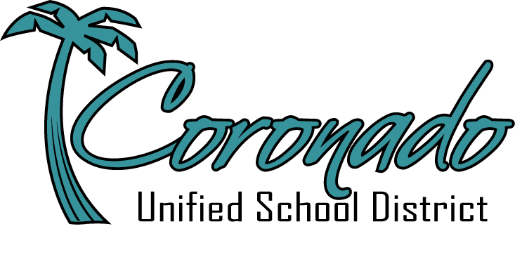


Silver Strand Elementary School
1350 Leyte Road, Coronado, CA 92118
Quality Education for Life Jennifer Moore, Principal 619.522.8934 www.coronadousd.net

Dear Silver Strand Military Families,

Welcome, Voyager students and families, to the Silver Strand Elementary School 2023-24 school year! We are proud and grateful to support this unique, small, and special school in Coronado Unified School District and to serve Silver Strand’s dedicated and inspiring staff, kind and curious students, and generous and involved families and community members. Silver Strand Elementary is a proud Purple Star School and we extend a warm welcome to our military families, recognizing the unique gifts and challenges associated with families who serve. Silver Strand Elementary and Coronado Unified School District are proud to offer robust resources for students and families to assist with transitioning into our school and community and feeling supported and valued while you are here. We have a variety of programs and personnel to support our military-connected families:

- Naval Base Coronado School Liaison Officer (SLO) – The SLO helps coordinate support for military families across the Coronado Unified School District and at other districts in South County. The SLO’s core services are: transition and deployment support, special needs system navigation, and post-secondary preparation. Contact info: nbcslo@us.navy.mil or (619) 991-2509.

- Military and Family Life Counselor (MFLC) – Our MFLC provides a variety of counseling services for military students and families, including Military Kids Club, counseling groups, 1:1 counseling, and deployment and transition support. Contact info: MFLC.Strand@coronadousd.net or (619) 592-0093.

- Anchored4Life - Anchored4Life is a transition and resiliency program designed to teach and reinforce life skills and build confident leaders. Student Anchored4Life Team Leaders welcome new students and orient them to our school, plan activities and service projects, and lead assemblies and promote positivity and community on campus.

- Operation Bigs - This program provides 1:1 mentoring for military students provided by adult volunteers via Big Brothers and Sisters of San Diego County. Interested families may call 858-746-9128.

- Operation Pals - Operation Pals offers after-school mentoring for military students provided by active-duty service member volunteers. This program takes place after school in sessions throughout the school year.

- Tutor.com/military - Free live one-on-one student tutoring, as well as assistance for parents to learn how to best support their student, available 24/7.

- Silver Strand Military Child Youth Center (across from school) - Before and after school care are available. More information can be found at www.militarychildcare.com.

Students may be referred to these programs by their teachers or by families. Please let us know if we can be of assistance to you as you transition to our school. Welcome to the Silver Strand Voyager Family!

Sincerely,

Jenny Moore
Principal
Jennifer.moore@coronadousd.net

